**Computer Network**

Assignment 01

Submitted By:

**Abeer Ilyas**

Registration Number:

**200901055**

Instructor:

**Sir Faran Mehmood**

**BS CS 01 – B**

**Department of Computer Science**

**Institute of Space Technology, Islamab**

**Blog topic:** PlayStation Network Cyber Attack

**Servers used:** Apache2 and Nginx

1. **Testing Website on:**

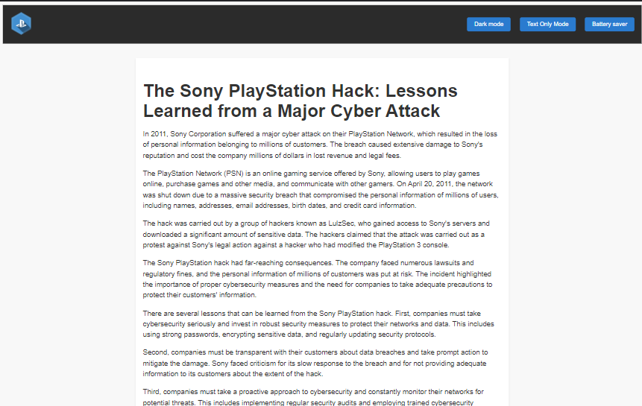

**Computer Screen**

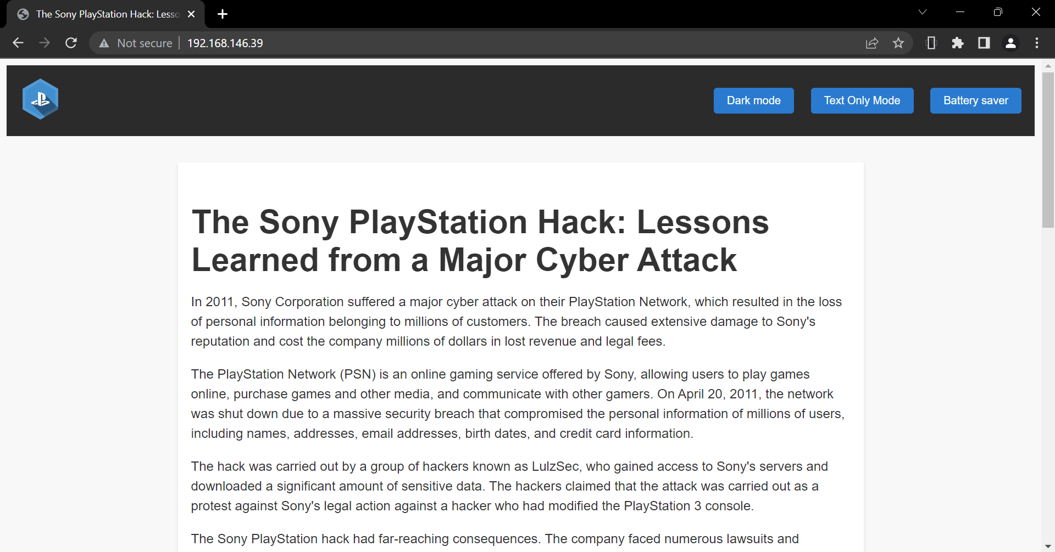

**Laptop**

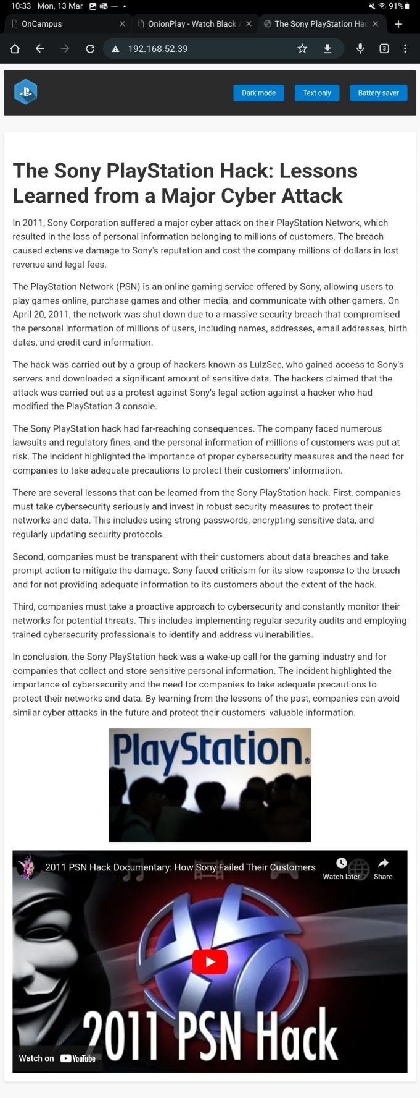

**Tablet**

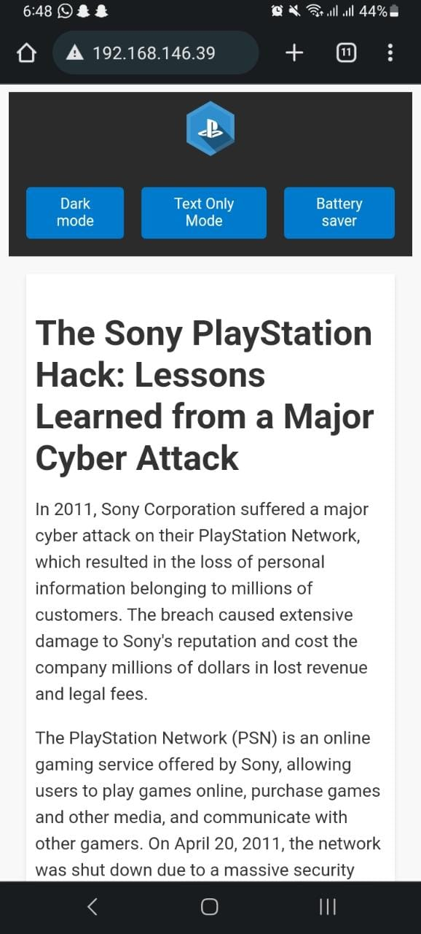

**Phone**

1. **Toggle Button Features:**

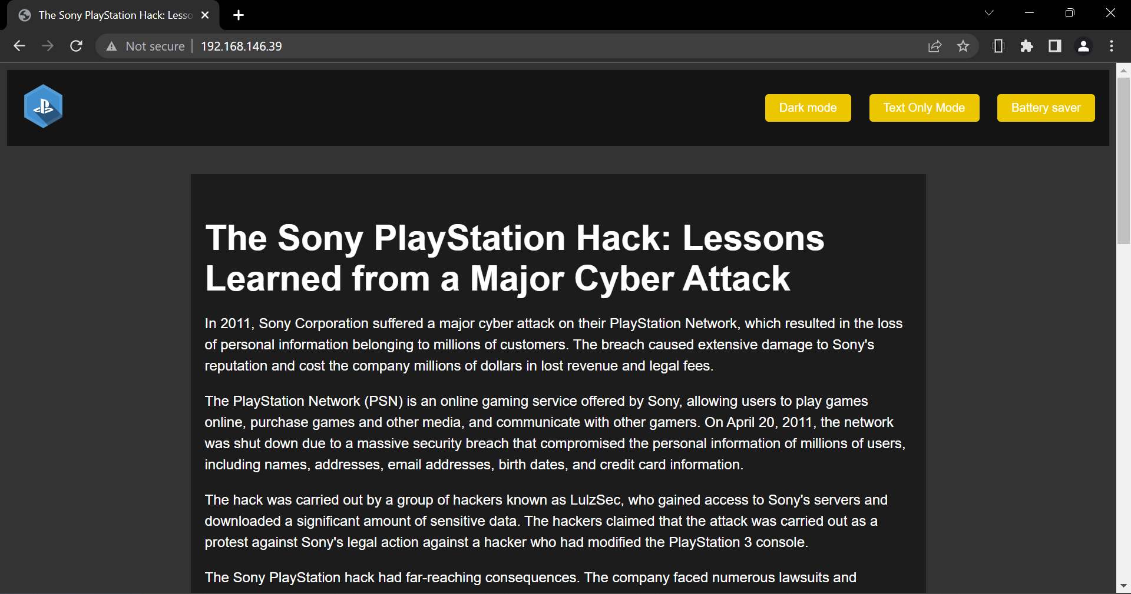

**Dark Mode**

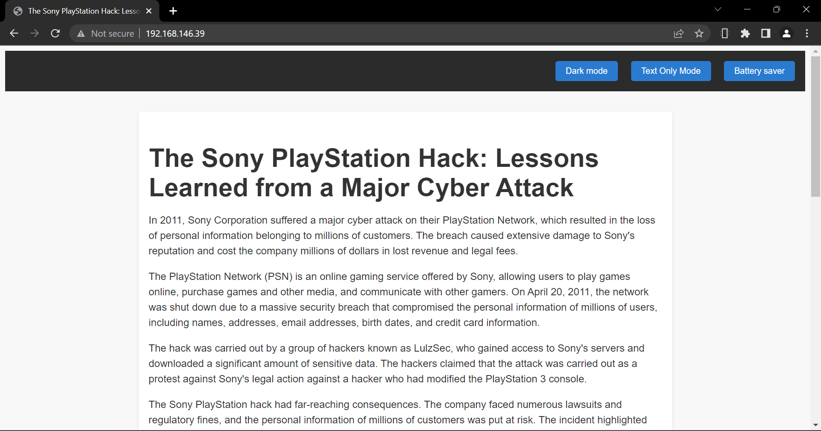

**Text Only Mode**

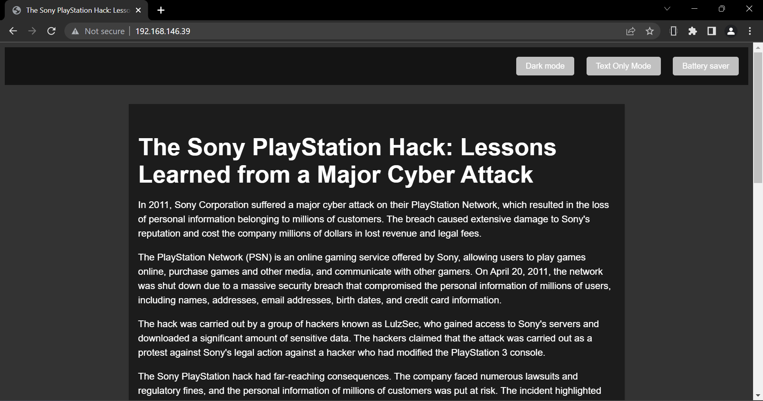

**Battery Saver Mode(automatically activates when the battery goes below 10%)**

1. **Comparing the performances of both the servers.**

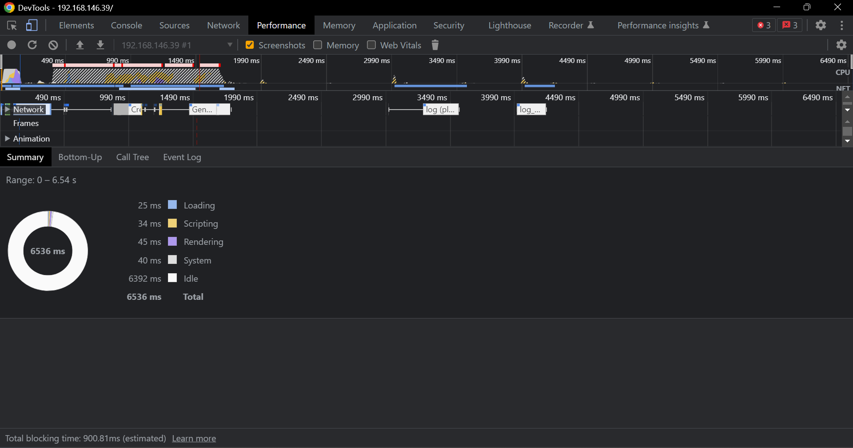

**Nginx**

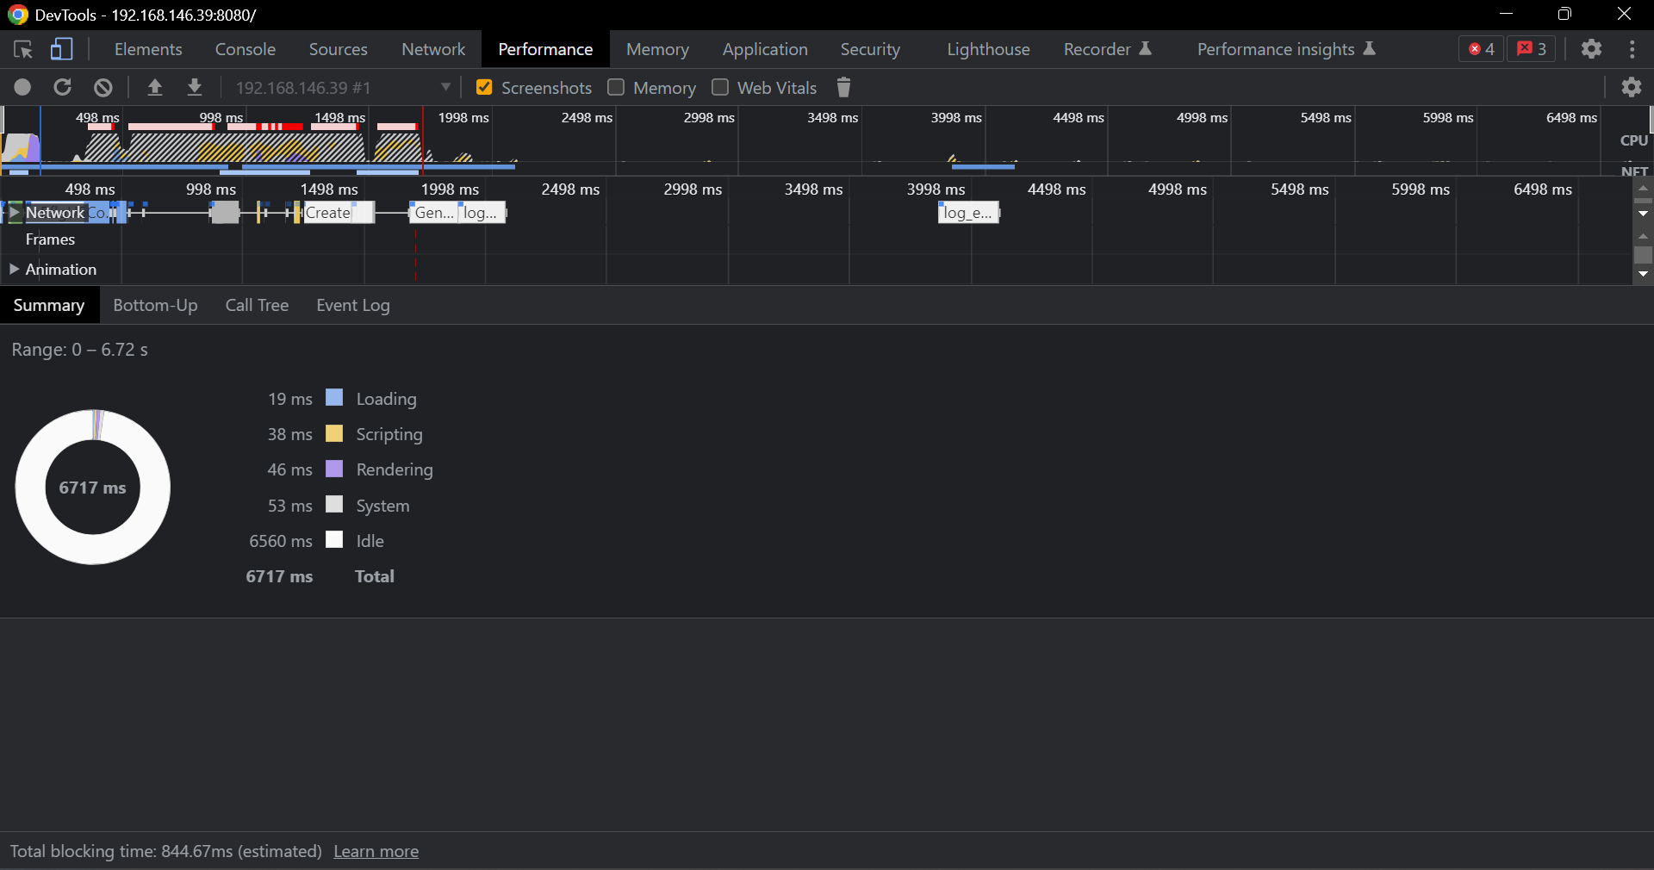

**Apache**

**Note:** To checkout the source code of my blog, kindly visit: <https://github.com/4833R11Y45/Web-Blog-about-Cyber-Attack-on-PSN-in-2011.>